# LOGS

Linux maintains various log files to help administrators track system activities and troubleshoot issues. Here are some common log files along with simple explanations:

1. */var/log/messages*

- *Explanation*: This is the primary log file that records a wide range of system events, including boot messages, service startup and shutdown, and general system errors.



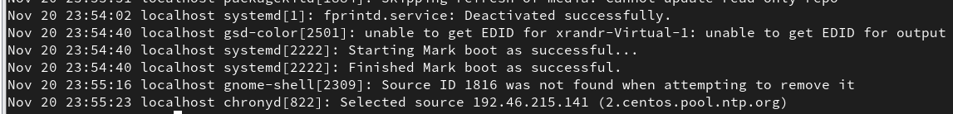

2. */var/log/secure*

- *Explanation*: This log file keeps track of security-related events, such as authentication attempts (successful and failed), sudo usage, and other securityrelated messages.





3. */var/log/cron*

- *Explanation*: Logs generated by the cron daemon, which schedules and executes periodic tasks, are recorded here.



4. */var/log/dmesg*

- *Explanation*: Contains kernel ring buffer messages, which are low-level system messages useful for diagnosing hardware and driver issues.

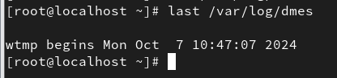

5. */var/log/boot.log*

- *Explanation*: Captures messages related to system boot processes, including the startup of various services.



6. */var/log/yum.log*

- *Explanation*: Tracks package installation, updates, and removal activities performed using the YUM package manager.

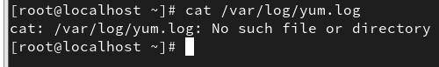

# LOGS

7. */var/log/audit/audit.log*

- *Explanation*: Stores audit logs generated by the Linux Auditing System, which is used for security auditing and monitoring.



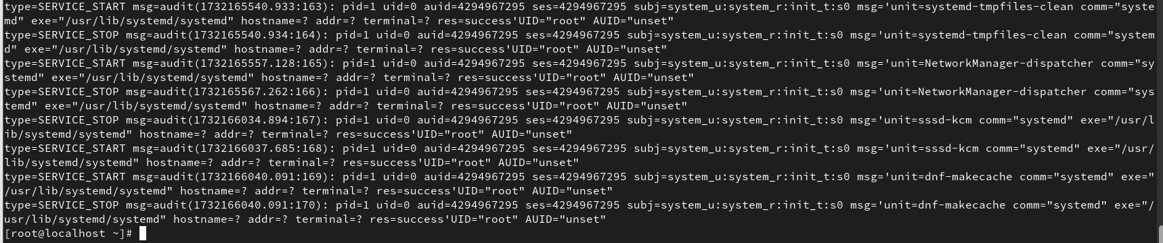

8. */var/log/httpd/*

- *Explanation*: Directory containing log files for the Apache web server, including access logs and error logs.

9. */var/log/maillog*

- *Explanation*: Logs related to the mail server, including messages sent and received, errors, and other mail server activities.

1. */var/log/lastlog*
   * *Explanation*: Records the last login time of each user. It is not a regular text file but can be viewed using the lastlog command.

1. */var/log/btmp*
   * *Explanation*: Records failed login attempts. Like lastlog, this is a binary file and can be viewed using the lastb command.

1. */var/log/wtmp*
   * *Explanation*: Records login and logout events. This binary file can be viewed using the last command.

These logs provide valuable information for monitoring system performance, identifying issues, and ensuring security. Regularly reviewing these logs can help maintain the health and security of a CentOS Linux system.